**VARIABLES And Data Types**

Variables are nothing but reserved memory locations to store values. This means that when you create a variable you reserve some space in memory.

Based on the data type of a variable, the interpreter allocates memory and decides what can be stored in the reserved memory. Therefore, by assigning different data types to variables, you can store integers, decimals or characters in these variables.

## Assigning Values to Variables

Python variables do not need explicit declaration to reserve memory space. The declaration happens automatically when you assign a value to a variable. The equal sign (=) is used to assign values to variables.

The operand to the left of the = operator is the name of the variable and the operand to the right of the = operator is the value stored in the variable.

counter = 100 # An integer assignment

miles = 1000.0 # A floating point

name = "John" # A string

print counter

print miles

print name

## Multiple Assignment

Python allows you to assign a single value to several variables simultaneously. For example −

a = b = c = 1

Standard Data Types

The data stored in memory can be of many types. For example, a person's age is stored as a numeric value and his or her address is stored as alphanumeric characters. Python has various standard data types that are used to define the operations possible on them and the storage method for each of them.

Python has five standard data types −

* Numbers
* String
* List
* Tuple
* Dictionary

**Python Numbers**

Number data types store numeric values. Number objects are created when you assign a value to them. For example −

var1 = 1

var2 = 10

You can also delete the reference to a number object by using the del statement. The syntax of the del statement is −

del var1[,var2[,var3[....,varN]]]]

You can delete a single object or multiple objects by using the del statement. For example −

del var

del var_a, var_b

Python supports four different numerical types

* int (signed integers)
* long (long integers, they can also be represented in octal and hexadecimal)
* float (floating point real values)
* complex (complex numbers)

## Python Strings

Strings in Python are identified as a contiguous set of characters represented in the quotation marks. Python allows for either pairs of single or double quotes. Subsets of strings can be taken using the slice operator ([ ] and [:] ) with indexes starting at 0 in the beginning of the string and working their way from -1 at the end.

The plus (+) sign is the string concatenation operator and the asterisk (*) is the repetition operator. For example

#!/usr/bin/python

str = 'Hello World!'

print str # Prints complete string

print str[0] # Prints first character of the string

print str[2:5] # Prints characters starting from 3rd to 5th

print str[2:] # Prints string starting from 3rd character

print str * 2 # Prints string two times

print str + "TEST" # Prints concatenated string

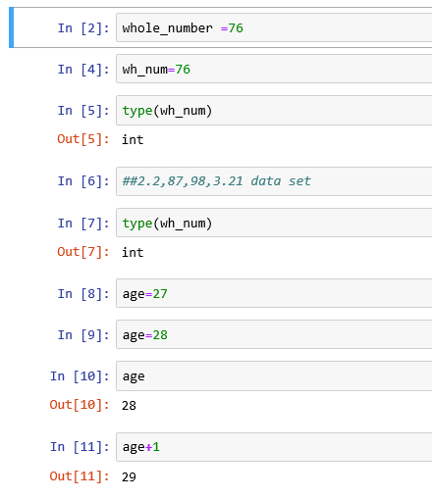

**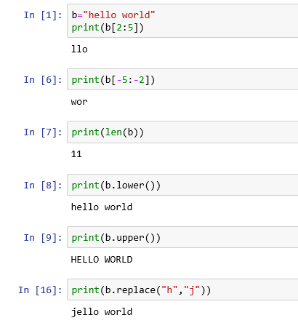  
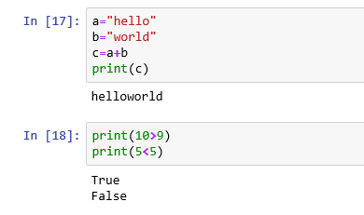**

## Operator in Python

Operators are the constructs which can manipulate the value of operands.

Consider the expression 4 + 5 = 9. Here, 4 and 5 are called operands and + is called operator.

**Types of Operator**

Python language supports the following types of operators.

* Arithmetic Operators
* Comparison (Relational) Operators
* Assignment Operators
* Logical Operators
* Bitwise Operators
* Membership Operators
* Identity Operators

Let us have a look on all operators one by one.

**Python Arithmetic Operators**

Assume variable a holds 10 and variable b holds 20, then −

|  |  |  |
| --- | --- | --- |
| **Operator** | **Description** | **Example** |
| + Addition | Adds values on either side of the operator. | a + b = 30 |
| - Subtraction | Subtracts right hand operand from left hand operand. | a – b = -10 |
| * Multiplication | Multiplies values on either side of the operator | a * b = 200 |
| /Division | Divides left hand operand by right hand operand | b / a = 2 |
| % Modulus | Divides left hand operand by right hand operand and returns remainder | b % a = 0 |
| ** Exponent | Performs exponential (power) calculation on operators | a**b =10 to the power 20 |
| // | Floor Division - The division of operands where the result is the quotient in which the digits after the decimal point are removed. But if one of the operands is negative, the result is floored, i.e., rounded away from zero (towards negative infinity) − | 9//2 = 4 and 9.0//2.0 = 4.0, -11//3 = -4, -11.0//3 = -4.0 |

**Python Comparison Operators**

These operators compare the values on either sides of them and decide the relation among them. They are also called Relational operators.

Assume variable a holds 10 and variable b holds 20, then −

|  |  |  |
| --- | --- | --- |
| **Operator** | **Description** | **Example** |
| == | If the values of two operands are equal, then the condition becomes true. | (a == b) is not true. |
| != | If values of two operands are not equal, then condition becomes true. | (a != b) is true. |
| <> | If values of two operands are not equal, then condition becomes true. | (a <> b) is true. This is similar to != operator. |
| > | If the value of left operand is greater than the value of right operand, then condition becomes true. | (a > b) is not true. |
| < | If the value of left operand is less than the value of right operand, then condition becomes true. | (a < b) is true. |
| >= | If the value of left operand is greater than or equal to the value of right operand, then condition becomes true. | (a >= b) is not true. |
| <= | If the value of left operand is less than or equal to the value of right operand, then condition becomes true. | (a <= b) is true. |

Python Assignment Operators

Assume variable a holds 10 and variable b holds 20, then −

|  |  |  |
| --- | --- | --- |
| **Operator** | **Description** | **Example** |
| = | Assigns values from right side operands to left side operand | c = a + b assigns value of a + b into c |
| += Add AND | It adds right operand to the left operand and assign the result to left operand | c += a is equivalent to c = c + a |
| -= Subtract AND | It subtracts right operand from the left operand and assign the result to left operand | c -= a is equivalent to c = c - a |
| *= Multiply AND | It multiplies right operand with the left operand and assign the result to left operand | c *= a is equivalent to c = c * a |
| /= Divide AND | It divides left operand with the right operand and assign the result to left operand | c /= a is equivalent to c = c / a |
| %= Modulus AND | It takes modulus using two operands and assign the result to left operand | c %= a is equivalent to c = c % a |
| **= Exponent AND | Performs exponential (power) calculation on operators and assign value to the left operand | c **= a is equivalent to c = c ** a |
| //= Floor Division | It performs floor division on operators and assign value to the left operand | c //= a is equivalent to c = c // a |

## Python Logical Operators

There are following logical operators supported by Python language. Assume variable a holds 10 and variable b holds 20 then

|  |  |  |
| --- | --- | --- |
| **Operator** | **Description** | **Example** |
| and Logical AND | If both the operands are true then condition becomes true. | (a and b) is true. |
| or Logical OR | If any of the two operands are non-zero then condition becomes true. | (a or b) is true. |
| not Logical NOT | Used to reverse the logical state of its operand. | Not(a and b) is false. |

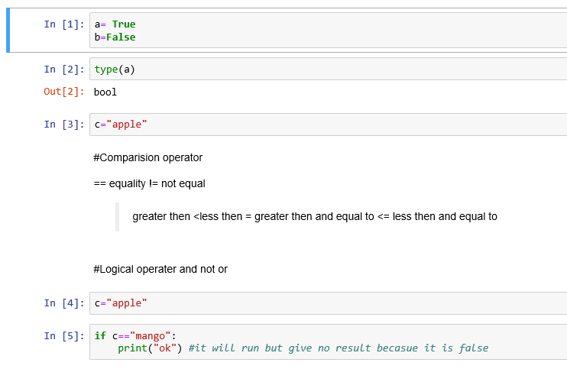

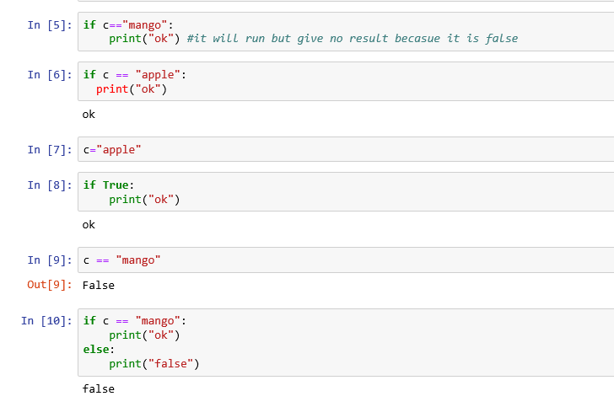

**TASK:**

Make the calculator and conditional statement that show the use of different operators.

**TASK:**

Create variables for different operations of your choice which covers arithmetic operations and take data input of any data type.